Stage 1 - Typescript
Stage 2 - Playwright (Web Automation)
Stage 3 - Hybrid Framework (Data Driven Framework, Page Object Model, Keyword Driven Framework)

Typescript Concepts
- Introduction of Typescript
  - A superset of javascript.
  - TypeScript adds type to JavaScript and helps to avoid potential bugs that occur during runtime
  - TypeScript also implements future features of JavaScript
- Architecture of TypeScript
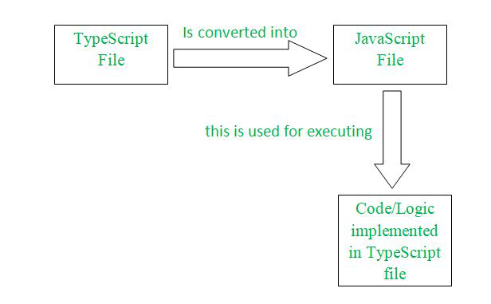
- Configure typescript at system level (optional)
  - Install Nodejs - https://nodejs.org/en
  - Install (Don’t install at global level)
npm install -g typescript
npm install -g ts-node

- Demo on running the typescript file using tsc/node and ts-node

To work on typescript
- Install VS code
- Create a project and open it in VS Code
- Set up TypeScript in VS Code
  - Set-ExecutionPolicy RemoteSigned -Scope CurrentUser (in case of any errors)
  - npm init -y
    - Update package.json
      - "type": "module"
  - npm install -D typescript ts-node @types/node
  - npx tsc –init
    - Update tsconfig.json

- UpperCameCase - MyFirstProject
lowerCamelCase - myFirstProject

- Datatypes
- Debugging
  - Continue
  - Stop
- Variable
  - In the module (.ts)
  - Inside the class (static and non-static variables)
    - How to declare and call a static variable?
      - Classname.variablename
    - How to declare and call a non-static variable?

- Methods - reusable, maintenance
  - In the module (.ts)
  - Inside the class (static and non-static methods)
- Access modifier
  - Private - accessible within the class
  - Protected - accessible within the class and also in the child class
  - Public - accessible anywhere
- Class - a class is a template, type, or blueprint from which objects are created.
- Object
  - An object is an instance of a class
  - Every object has its own state (non-static variable) and behaviour (non-static method)
- Constructor
  - It gets called whenever an object is created. It is used to initialize a non-static variable.
- this
  - Helps to distinguish between instance and local variables
  - this keyword - points to the current object
- Encapsulation
  - A principle that bundles data (variables) and the methods (functions) that operate on that data into a single unit
- How to work an asynchronous method

Reference
Error 1:
PS C:\typescript-playwright> npm init -y
npm : File C:\Program Files\nodejs\npm.ps1 cannot be loaded because running scripts is disabled
on this system. For more information, see about_Execution_Policies at
https:/go.microsoft.com/fwlink/?LinkID=135170.
At line:1 char:1
+ npm init -y
+ ~~~
+ CategoryInfo : SecurityError: (:) [], PSSecurityException
+ FullyQualifiedErrorId : UnauthorizedAccess

Note 2:
CommonJS (CJS) and ES Modules (ESM) are JavaScript systems for structuring code, with CJS being the synchronous, traditional Node.js standard using require()/module.exports, and ESM being the modern, asynchronous, standard ECMAScript format using import/export

